AMRITA SCHOOL OF ENGINEERING
23RAI398 MINI PROJECT

ASSIGNMENT – 3

Sensors, Actuators & Control Architecture (Conceptual)
A C Anirudh | BL.EN.U4RAE23003
Nihal P | BL.EN.U4RAE23029
S Venkata Rami Reddy | BL.EN.U4RAE23038

1. System Overview:
Aspect | Description
System Description | QUANC is a duck-inspired indoor companion robot that performs environmental monitoring, presence detection, and simple interaction using rule-based control.
Key Functionality | Monitor environment (gas, temperature, light), detect human presence, provide expressive interaction, send alerts to caregivers.
Input Parameters | Sensor data from gas, temperature, humidity, light, camera/proximity, touch/IMU.
Output Actions | Eye/head movement, robot locomotion, alerts/notifications to caregiver.
Operating Environment | Indoor home environment; moderate lighting, flat surfaces, human presence.
Constraints | Limited budget, compact size, battery power, indoor-only operation.
Assumptions | Stable indoor conditions, minimal obstacles, basic user interaction, simplified sensing models.

2. Sensor Selection:
Sensor Name | Type (Analog/Digital) | Purpose | Working Principle | Range/Accuracy | Interface | Justification
MQ-2 Gas Sensor | Analog | Detect gas leakage | Resistance change with gas concentration | ~200–10000 ppm | ADC | Low cost, reliable for hazard detection
DHT11 / DHT22 | Digital | Temperature & humidity sensing | Capacitive + thermistor | ±2°C, ±5% RH | Single-wire | Simple and sufficient for indoor monitoring
LDR (Light Sensor) | Analog | Ambient light detection | Resistance varies with light | Low precision | ADC | Cheap and effective for light sensing
Camera Module | Digital | Presence / posture detection | Image capture + CV processing | Algorithm dependent | CSI / USB | Enables visual awareness
Ultrasonic / ToF Sensor | Digital | Distance / proximity sensing | Time-of-flight measurement | 2–400 cm | GPIO / I2C | Works as fallback for presence detection
IMU (MPU6050) | Digital | Orientation & balance | Accelerometer + gyroscope | High sensitivity | I2C | Essential for biped stability
Touch Sensor | Digital | User interaction | Capacitive sensing | Binary | GPIO | Enables simple interaction
Microphone Module | Analog/Digital | Sound/event detection | Converts sound waves to electrical signals | Depends on module | ADC / GPIO | Detects calls, sudden sounds, or activity

3. Actuator Selection:
Actuator Name | Type | Function | Specifications | Power Requirement | Control Method | Justification
BLDC / DC Motor + Gearbox | Rotary | Hip pitch (forward/back leg motion) | High torque, geared output | High | PWM + Motor Driver | Provides required torque and efficiency for primary locomotion
Servo Motor (High Torque) | Rotary | Hip roll (side balance) | ~10–20 kg·cm torque | Medium | PWM | Precise lateral balance control
Pneumatic Spring | Linear (Passive) | Knee joint support | Force based on body weight | None (passive) | Mechanical | Reduces control complexity and energy usage
Servo Motor (Medium Torque) | Rotary | Ankle stabilization | ~5–10 kg·cm torque | Medium | PWM | Maintains balance and foot orientation
Servo Motor (SG90) | Rotary | Head and eye movement | Low torque | Low | PWM | Enables expressive interaction
Buzzer / Speaker | Audio | Feedback / alerts | Basic audio output | Low | GPIO / PWM | Provides sound-based feedback
OLED / LED Display | Visual | Eye expressions / status | Small display module | Low | I2C / SPI | Improves user interaction and feedback

4. Control Unit:
Parameter | Details
Controller Name | ESP32 + Raspberry Pi 5
Type | Microcontroller (ESP32) + Microprocessor (Raspberry Pi)
Processing Capability | ESP32: Dual-core, ~240 MHz; Pi: Multi-core, GHz-level
Input/Output Interfaces | GPIO, ADC, PWM, I2C, SPI, UART
Communication Protocols | I2C, SPI, UART, WiFi, Bluetooth
Power Consumption | ESP32: Low–Medium; Pi: Medium–High
Cost | ESP32: ₹500; Pi: ₹10,000

Justification Table
Criteria | Explanation
Why this controller? | ESP32 handles real-time control; Raspberry Pi handles CV and higher-level processing
Compatibility | Supports all selected sensors and actuators with standard interfaces
Scalability | Easy to expand with additional sensors or modules
Cost-effectiveness | ESP32 keeps base cost low; Pi is optional based on need
Ease of Implementation | Strong community support and available libraries

5. System Block Diagram:
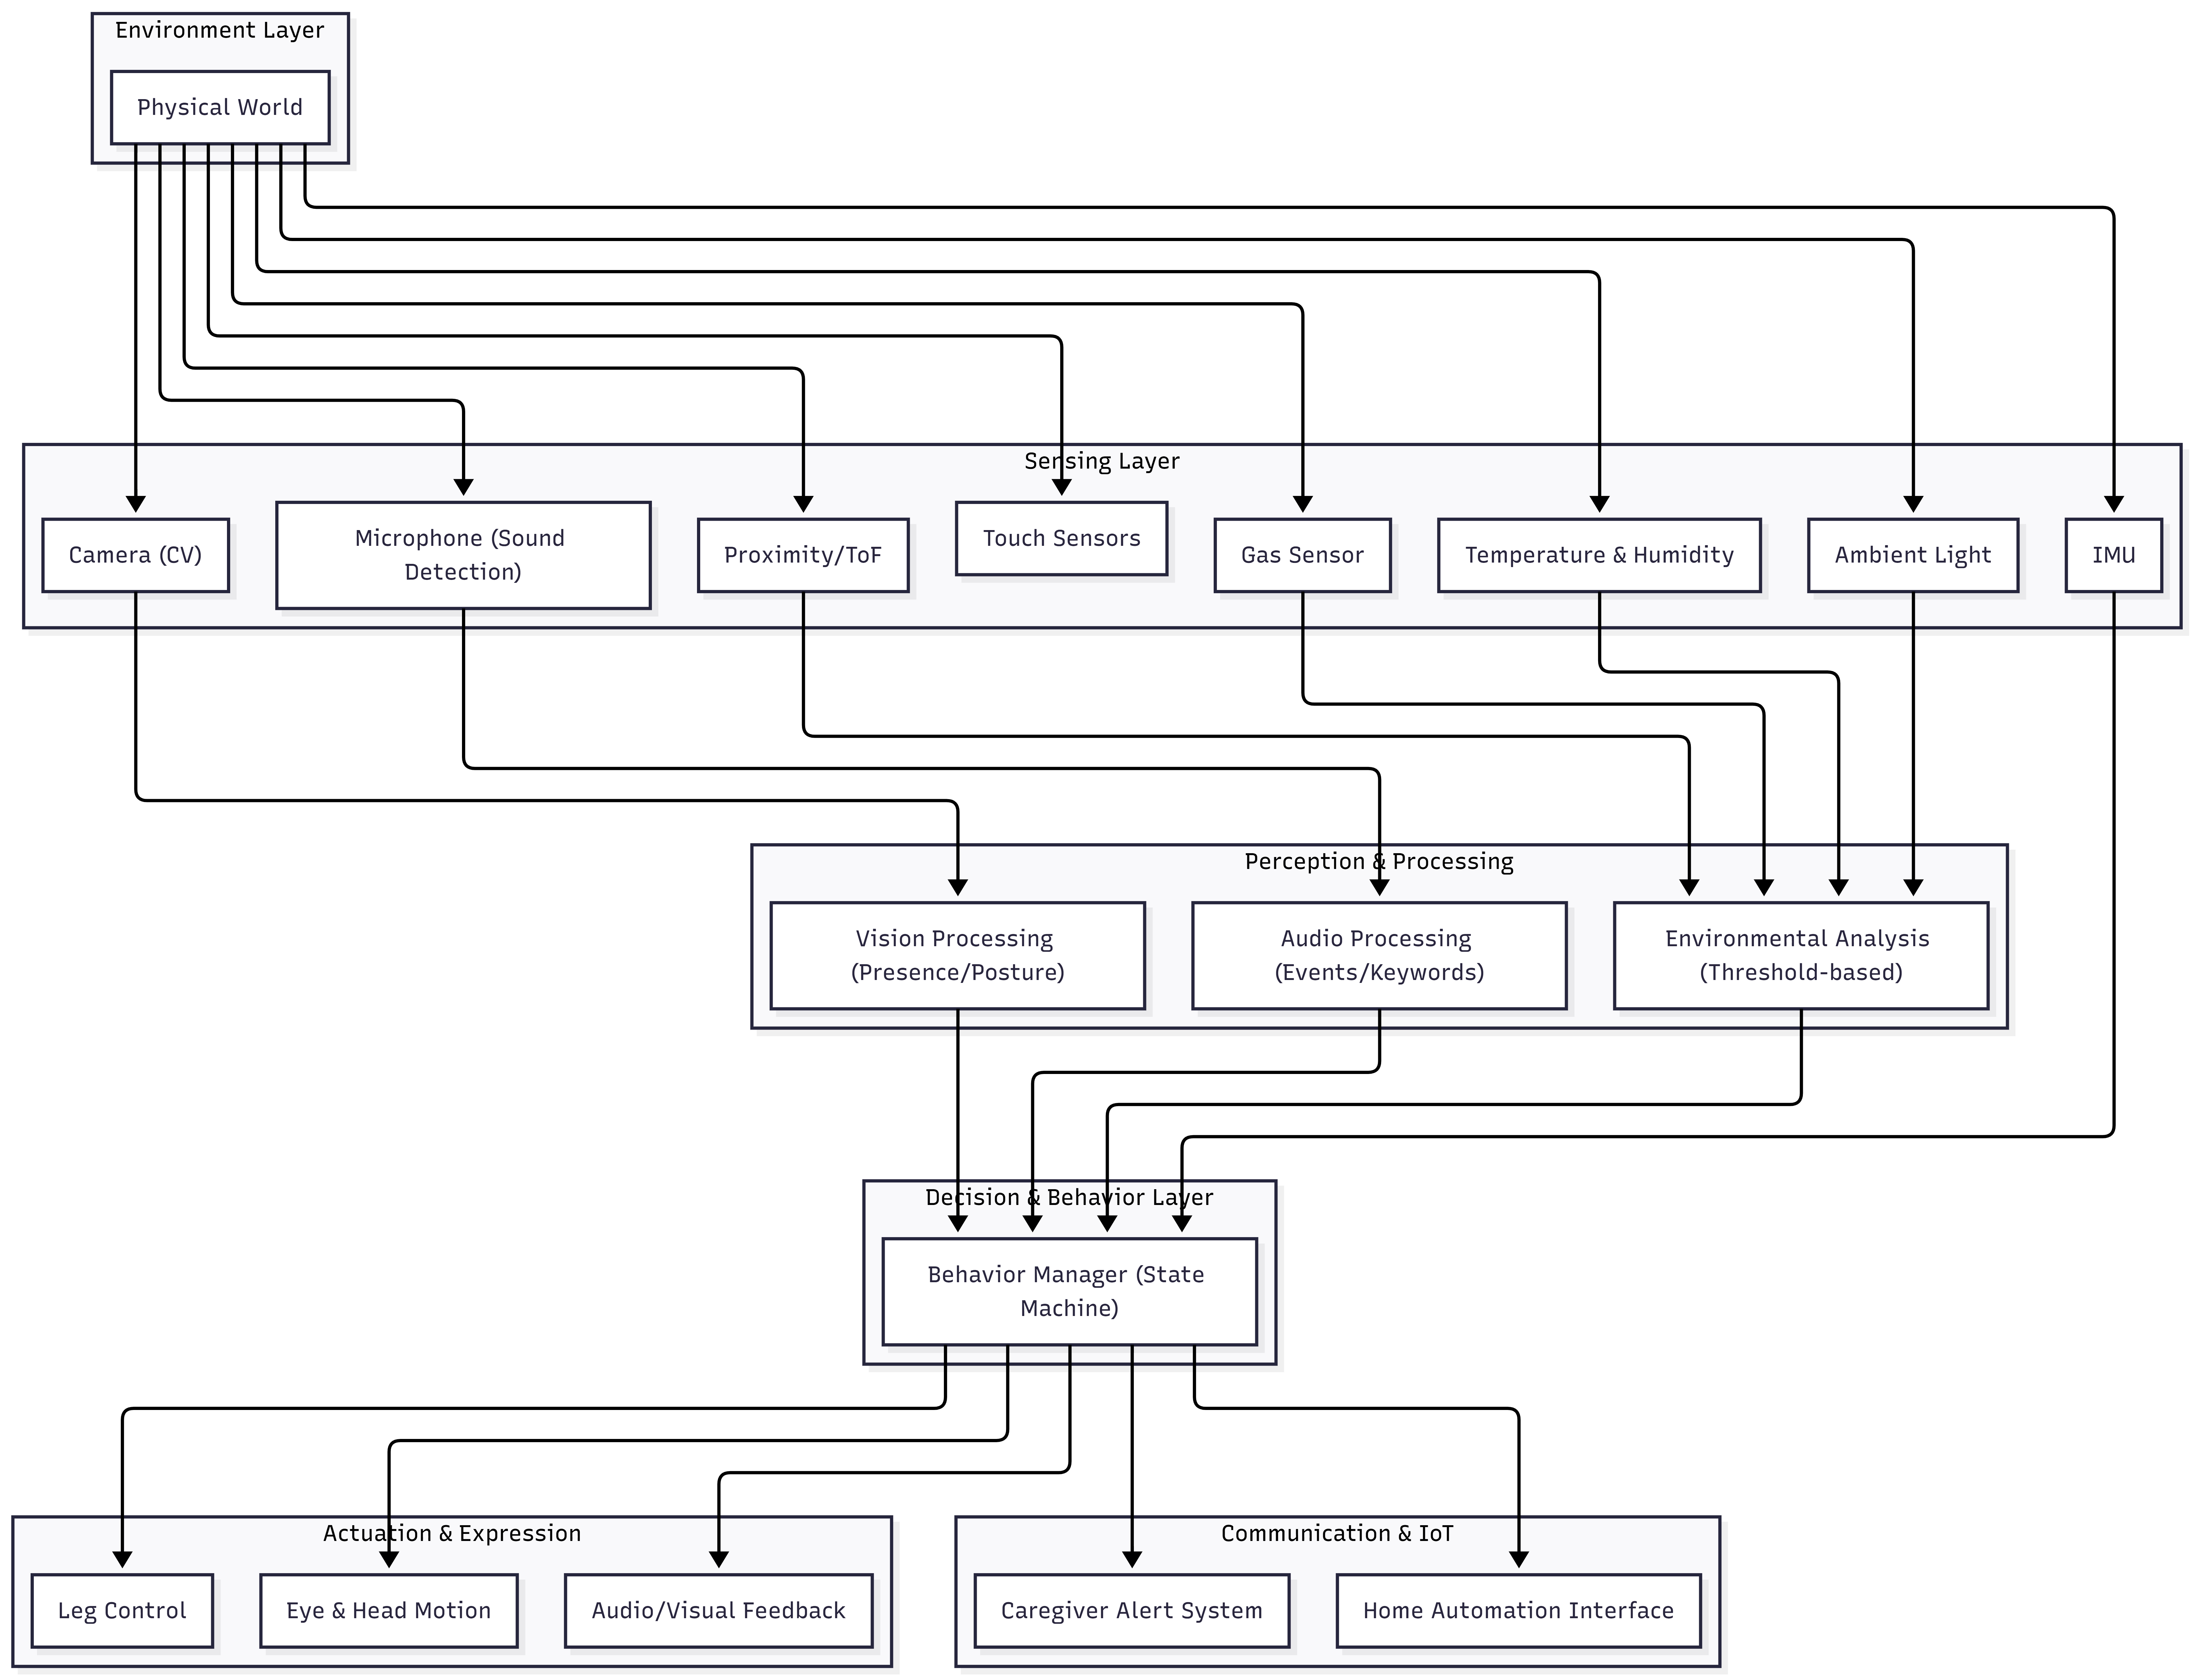

6. Control Logic: Flowchart or pseudocode
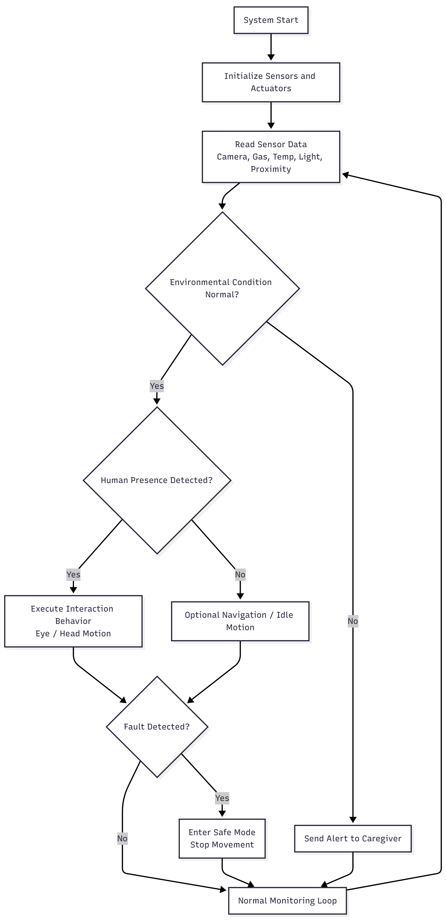
Start
INITIALIZE sensors
INITIALIZE actuators
WHILE system_is_running:
// --- Read Sensors ---
sensor_data = READ_SENSORS()
camera = sensor_data.camera
gas = sensor_data.gas
temperature = sensor_data.temperature
light = sensor_data.light
proximity = sensor_data.proximity

// --- Check Environment ---
IF NOT ENVIRONMENT_IS_NORMAL(sensor_data) THEN
SEND_ALERT_TO_CAREGIVER()
CONTINUE // skip rest of loop, go to next cycle
ENDIF

// --- Human Detection ---
IF HUMAN_PRESENT(camera, proximity) THEN
EXECUTE_INTERACTION_BEHAVIOR()
// e.g., eye motion, head movement
ELSE
EXECUTE_IDLE_OR_NAVIGATION()
ENDIF

// --- Fault Detection ---
IF FAULT_DETECTED() THEN
ENTER_SAFE_MODE()
STOP_MOVEMENT()
ENDIF

// --- Loop Delay / Monitoring ---
WAIT(dt)
END WHILE
END

7. Integration:
Sensor Interaction
Sensors continuously collect environmental and interaction data:
- Analog signals: Gas sensor, LDR, microphone
- Digital signals: IMU, camera, ToF, touch, temperature/humidity
These inputs represent environmental state, user presence, and robot condition.
Controller Processing
The ESP32 processes real-time sensor data using rule-based logic and a finite state machine (FSM).
- Environmental data is compared against thresholds
- Presence data triggers interaction behaviors
- CV (if used) runs on Raspberry Pi and sends processed results to ESP32
Decision-making is based on IF–ELSE conditions and system states.
Actuator Response
Based on decisions:
- Hip (BLDC/DC + gearbox): drives forward motion
- Hip roll & ankle (servo): maintain balance
- Knee (passive pneumatic spring): supports motion
- Head/eyes: provide expressive feedback
- Buzzer/display: alert or communicate status
Outputs result in movement, interaction, or alerts to caregiver.

8. Safety & Feasibility:
Safety
- Operates at low speed to prevent injury or damage
- Implements fail-safe behavior: stop motion on fault or instability
- Uses lightweight structure to reduce impact risk
- Electrical components are properly regulated and insulated
- Avoids continuous recording → privacy-safe design

Feasibility
- Technically feasible as a prototype with simplified walking and rule-based control
- Biped design is challenging but manageable with slow gait and passive knee support
- Uses readily available components (ESP32, sensors, servos)
- Cost can be controlled by limiting advanced features (CV optional)
- Modular design allows incremental development and testing

